PROBLEM: 1. Write a C++ program to delete an array element using its index number.

CODE:

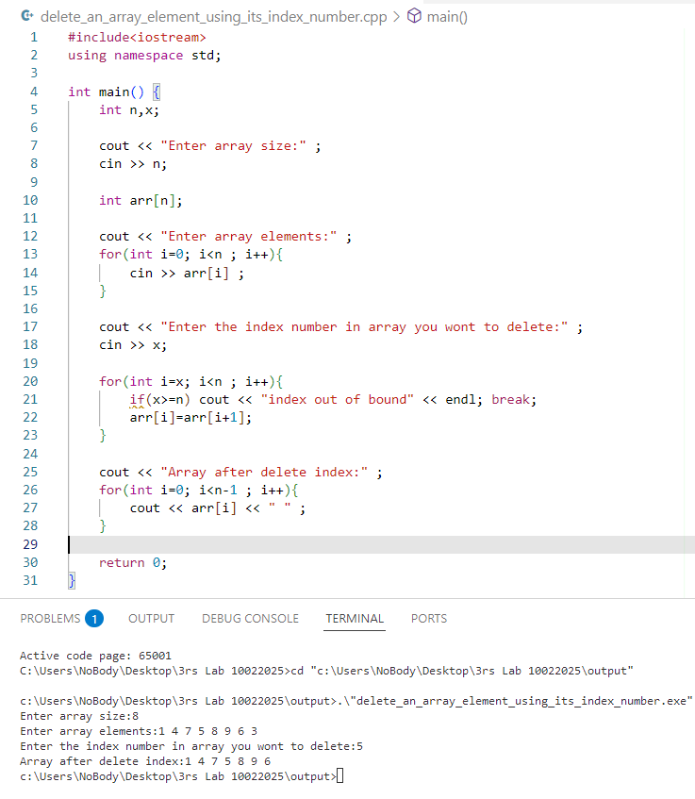

PROBLEM: 2. Write a C++ program to delete an array element by its value using linear search.

CODE:

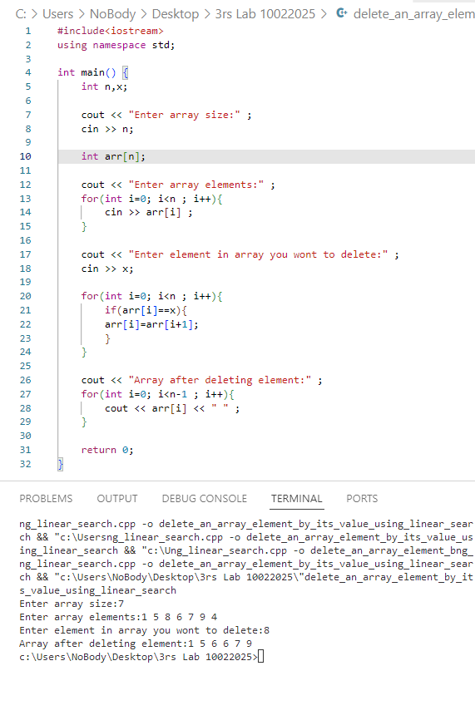

PROBLEM: 3. Write a C++ program to perform a binary search on an array.  
CODE:

